Jimmie Jackson is Retiring after
40 Years of Service with RG&E/IUMC!
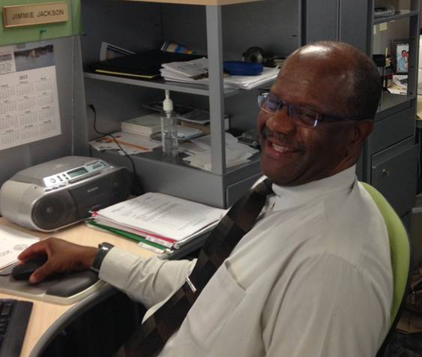
Please come wish Jimmie well in his retirement
When: Wednesday, July 31st
Time: 6:30 pm
Where: Valicia's Ristorante at 2155 Long Pond Rd, Rochester
Cost: $20.00 – includes dinner and gift

Please contact: Nicole Duris at 724-8028 or email nicole.duris@iberdrolausa.com by July 26th.

